**Team Information**

Supervisor: Mohammed Ali

Group: 5.WED-1430-4

|  |  |
| --- | --- |
| **Student ID** | **Name** |
| Brenton Manks | s3078901 |
| Si Long Leong | s3785099 |
| John Lam | s3681915 |
| Mohammed Abdullah H Almahdawi | s3761295 |
| Jonathan Vernik | s3786227 |

GitHub:

<https://github.com/RMIT-SEPT/majorproject-5-wed-1630-4>

TrelloBoard: <https://trello.com/invite/b/J1ZhzMzz/1426190fe915ef59313a0b78cb4ad7f5/sept-group-4>

MS Teams: <https://teams.microsoft.com/l/channel/19%3a0cef6f6b61464e2388920c4bbefb7861%40thread.tacv2/General?groupId=7c0c37b4-d99e-4b9b-82ca-3d3b55f208bb&tenantId=d1323671-cdbe-4417-b4d4-bdb24b51316b>

CI:

<https://app.circleci.com/pipelines/github/RMIT-SEPT/majorproject-5-wed-1630-4>

Screenshot of the AGME app logs being displayed in CloudWatch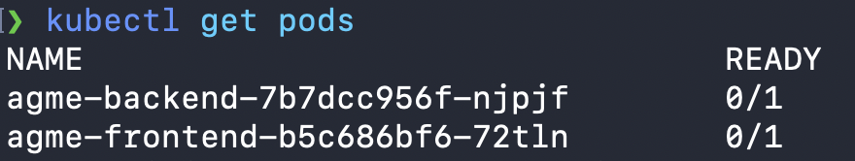

It should be noted that we deployed the kubernetes cluster to a local Virtual machine using minikube.

